Chapter 3 - Earth’s Dynamic Surface Lesson 1 - Earth’s Moving Surface
Plate Tectonics
During the 1960s, scientists developed a theory to explain many of the features on Earth’s surface.
The theory is called plate tectonics and states that Earth’s surface is broken into large, rigid pieces that move with respect to each other. These pieces, or tectonic plates, move slowly over Earth’s surface.
What is a tectonic plate?
Earth is made of layers of material. The outermost layer is called the crust.
Lithosphere
Earth’s outermost layer is called the crust. The crust and uppermost part of the mantle make up the lithosphere .
The lithosphere forms a rigid shell on the outside of Earth. However, the lithosphere is broken into large pieces. These pieces are tectonic plates.
Asthenosphere
The partially melted portion of the mantle below the lithosphere is the asthenosphere.
The asthenosphere is hotter than the lithosphere and can bend more easily.
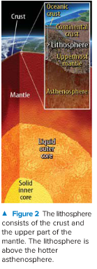
Major Tectonic Plates
Scientists have identified 15 large tectonic plates within Earth’s crust, as shown in the figure below.

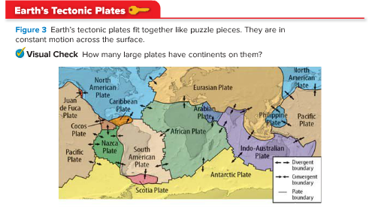

- Some plates are so large they support entire continents. Other plates are so small that a map of this scale cannot represent them.
- Earth’s tectonic plates fit together like puzzle pieces.
- The plates are in constant motion across Earth’s surface.
- The largest plate is the Pacific Plate.
- Oceans completely cover some plates, such as the Juan de Fuca Plate.
- Other plates, such as the North American Plate, are made of both oceanic crust and continental crust.

Plate Boundaries
Scientists describe a plate’s relative motion—how it moves in relation to another plate.
For example, the North American Plate is moving away from the Eurasian Plate, but it is also moving toward the Pacific Plate.

As plates move relative to each other, different types of boundaries form where the plates meet.

The type of boundary that forms depends on the relative motion of the plates.
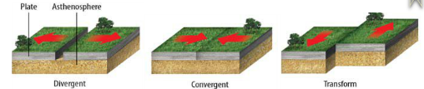
There are three type of plate boundaries:
- Divergent Boundary
- Convergent Boundary
- Transform Boundary
Divergent Boundaries
A boundary where two plates move away from each other is called a divergent boundary.
Example: The boundary between the North American Plate and the Eurasian Plate is a divergent boundary. As plates move apart, new crust forms between them.

Convergent Boundaries
A boundary where two plates move toward each other is a convergent boundary.
In some locations, one plate is pushed under the other plate and down into the mantle. That plate melts and becomes part of the mantle.
Subduction is the process that occurs when one tectonic plate moves under another tectonic plate. At a convergent boundary, the process of subduction forces one plate into the mantle.
Example: The Pacific Plate is subducting under the North American Plate at the convergent plate boundary near Alaska.
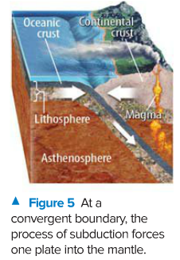
Transform Boundaries
Two plates slide past each other at a transform boundary.
Example: The boundary between the Pacific Plate and the North American Plate in California is an example of a transform boundary.
Measuring Plate Movement
- Tectonic plates move horizontally over Earth’s surface.
- The plates move so slowly that geologists could not measure their movement before the mid-twentieth century. However, during the 1970s, scientists and engineers developed new technologies that made it possible for them to measure how fast tectonic plates move.
- This technology has determined that North America is separating from Europe at an average rate of just 2.5 cm/y.

The position of any point on Earth’s surface can be accurately measured using the network of satellites known as the Global Positioning System (GPS).
By tracking tectonic plate positions over several years, scientists can measure the speed and the direction of plate movement.
Even though plates move slowly, dramatic changes occur over long periods of time.
For example, North America and Europe once were part of a large continent called Pangaea.
A divergent boundary formed between North America and Europe about 200 million years ago. The plates moved apart, and the Atlantic Ocean formed.

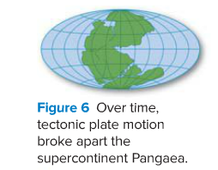

Why do tectonic plates move?
Convection
- To understand convection you have to recall that density is the amount of matter per unit of volume.
- As the temperature of a fluid increases, the molecules in the fluid spread out. There is less matter in the same amount of volume. So, the fluid becomes less dense.
- However, fluids do not heat evenly. Some of a fluid can be warmer and less dense, while some is cooler and more dense.
- The warmer, less dense fluid rises, and the cooler, denser fluid sinks. The circulation within fluids caused by differences in density and thermal energy is called convection.
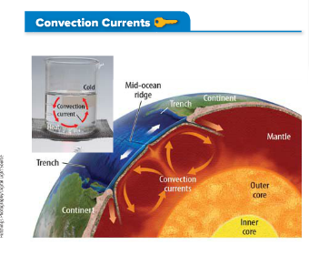
Convection occurs in Earth’s asthenosphere, the layer just below the lithosphere.
- Rocks in the mantle are hot enough to bend easily. They can flow in a way similar to how fluids flow.
- Convection in the mantle can drag plates over the surface of Earth, as illustrated in the figure below.
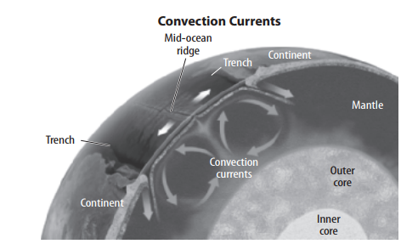
As the mantle convects, it pulls and pushes the tectonic plates.

Subduction
- Another process that causes plate movement is subduction.
- A plate at Earth’s surface is colder and denser than the mantle below it. When two plates collide, one can subduct or sink into the hotter, less-dense mantle.
- When this happens, the sinking part of the plate pulls the rest of the plate along with it.
An example of subduction is below:
